Asia-Bactrian - Margiana stone sculpture-AFghanistan -14 x 9 c m

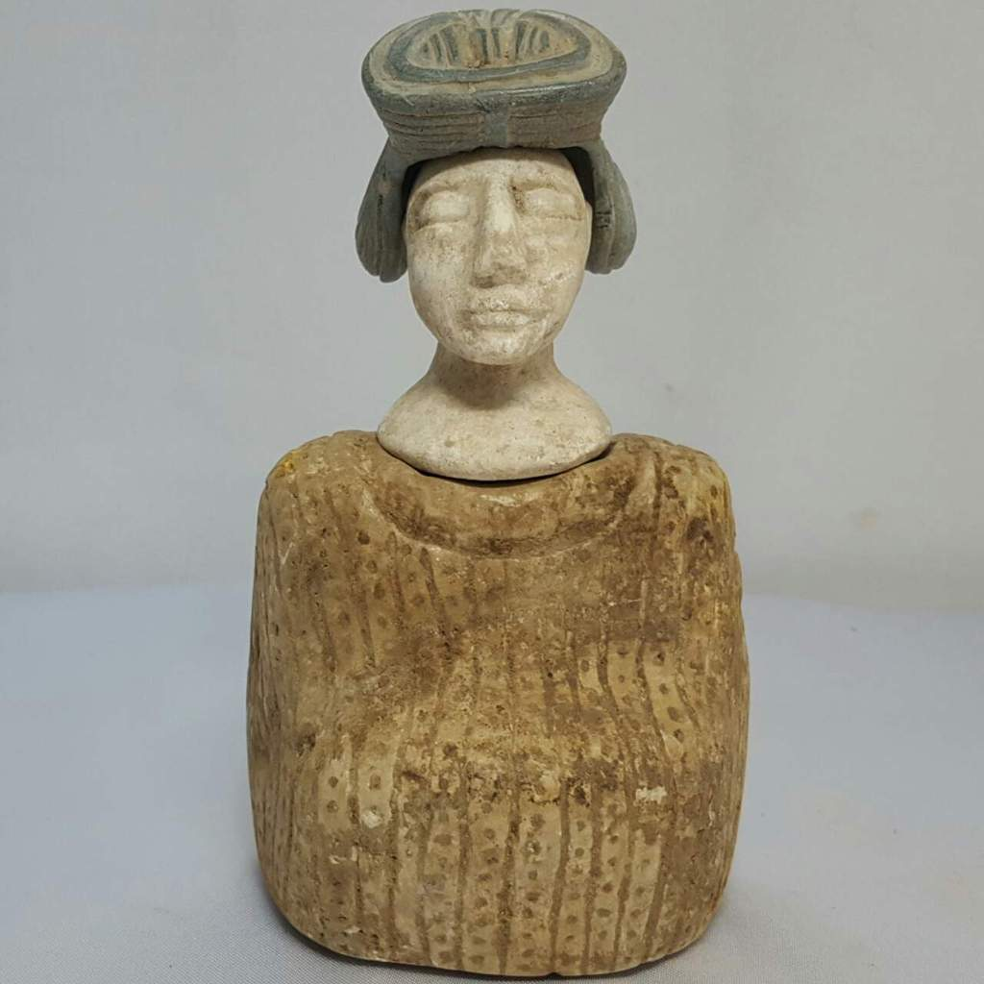

|  |
| --- |
|  |

# Rare Old Bactrian - Margiana stone sculpture

# Order details

## Sales order

Sold by [goldfingure](http://myworld.ebay.com/goldfingure) ( [8824](http://feedback.ebay.com/ws/eBayISAPI.dll?ViewFeedback&userid=goldfingure) )

Estimated delivery Thursday, Dec 22, 2016 - Thursday, Dec 29, 2016

#### [RARE ANCIENT INDUS VALLEY FERTILITY IDOL FROM THE HARAPPA CULTURE 3300-1200 BC](http://www.ebay.com/itm/201748693103)

|  |  |
| --- | --- |
| Item price | $82.57 |
| Quantity | 1 |
| Item number | 201748693103 |
| Shipping service | International Tracked Postage |

## Recently viewed items1/3

[Feedback on our suggestions](http://qu.ebay.com/survey?srvName=merchandising+(merch1)&extparam=pageid%3D2054502%26plmtid%3D100227)

## Shipping address

Ralph J Coffman Jr

149 Atlantic Ave

Swampscott MA 01907-2427

United States

## Order total

|  |  |
| --- | --- |
| Subtotal | $82.57 |
| Shipping | $17.78 |

**Total**

$100.35

*Pricing based on current conversion rates

Order placed on

Thursday, Dec 15, 2016

Payment method

PayPal

Payment date

Thursday, Dec 15, 2016